

Air Temperature and Relative Humidity Investigation

SUBJECT: Earth Science

GRADE LEVEL: 9th – 12th

DEPTH OF KNOWLEDGE LEVEL: 2

AUTHOR: Dr. Lawrence Rudd, School of Education, Nevada State College, [Lawrence.rudd@nsc.edu](mailto:Lawrence.rudd@nsc.edu)

NEXT GENERATION SCIENCE STANDARDS:

1. Design or refine a solution to a complex real-world problem, based on scientific knowledge, student-generated sources of evidence, prioritized criteria, and tradeoff considerations. (HS-ESS3-4)
2. Earth’s systems, being dynamic and interacting, cause feedback effects that can increase or decrease the original changes. (HS-ESS2-2)
3. Empirical evidence is required to differentiate between cause and correlation and make claims about specific causes and effects. (HS-ESS3- 1)
4. Science arguments are strengthened by multiple lines of evidence supporting a single explanation. (HS-ESS3-5)

PRIOR KNOWLEDGE: Students should know the basic weather variables, especially the different ways to express humidity. Students should also have made and interpreted graphs of earth science data.

INTRODUCTORY ACTIVITY: Use a psychrometer to find both temperature and the relative humidity of the air in the classroom over a period of five days. Measure temperature and relative humidity several times each day (or have several classes take measurements and merge the data). Make one or more graphs to show how these two weather variables change over this period of time. Compare your graph to the graph on page three of this investigation.

CONCEPT/SKILL DEVELOPMENT:

**Objective:**

The purpose of this investigation is to understand the relationship between relative humidity and temperature for a Transect Data Site.

**Driving Question:**

What is the relationship between relative humidity and temperature at a transect data site over a period of one week?

**Materials:**

Instructions (below)

Temperature and Relative Humidity graph for the Sheep Range Blackbrush Research Site

Access to the Nevada Climate Change Data Portal

**Important Terms:**

Relative Humidity

Temperature

Sheep Range

Blackbrushplant community zone

**Resources**

<http://www.weather.com/encyclopedia/>

Descriptions of a variety of storms and weather phenomena in an encyclopedic format.

<http://www.exploringweather.com/index.html>

A site that focuses on storms, as well as the process of weather forecasting. This site also includes a useful glossary of weather terms.

<http://sensor.nevada.edu/NCCP/Default.aspx>

The Nevada Climate Change Portal. This site explains the Nevada Climate Change project.

<http://daymet.ornl.gov/custom_home>

This site gives access to a model that provides weather data for North America from 1980 to 2011. Click on Daily Data for a Single Pixel in the left-hand column to get weather data for any location in North America.

**Investigation:**

**Examine the Temperature and Relative Humidity graph for the Sheep Range Blackbrush Research Site (Figure 1) and answer the following questions.**

1. Use the following site to view images of the Sheep Range Blackbrush site: <http://sensor.nevada.edu/NCCP/Climate%20Monitoring/Web%20Cameras.aspx>

Click on the Latest Images link in the Sheep Range Blackbrush bar to view images of this site. Write a brief description of the vegetation and topography of the area.

1. What type, frequency, and amount of precipitation do you think characterizes this area?

**Use the graph of Relative Humidity and Temperature vs. Date for the Sheep Range Blackbrush Research Site (Figure 1) to answer the following questions.**

1. Which day had the highest temperature, what was that temperature and what time of day did that temperature occur?
2. Which day had the lowest relative humidity value, what was that value, and when did it occur?
3. What is the general relationship between temperature and relative humidity through this one-week period during June of 2012?
4. Why do you think that the relationship you described in your answer to question #5 exists?
5. How do you think that this graph would change for a wetter, higher-elevation location in the Sheep Range such as the Pinyon-Juniper, Montane, or Subalpine zones?
6. How to you think that a temperature-relative humidity vs. time graph would look for a dryer, lower-elevation location, such as desert shrub? Draw a simple sketch graph to go along with your description. Look up images of these vegetation zones on the site:

<http://sensor.nevada.edu/NCCP/Climate%20Monitoring/Web%20Cameras.aspx>

1. Describe how your graph of temperature and relative humidity in your classroom compares to the graph below. Why do you think the similarities and differences exist?

**Extension**

Examine the graph closely during the early hours of the morning on June 16th. Briefly describe the shape of the temperature and relative humidity curves from midnight to noon on June 16th. Make two or three hypotheses about why the lines on the graph take this shape. What data would you need to gather to prove or disprove each of your hypotheses?

CLOSING ACTIVITY: Examine the water vapor capacity vs. air temperature graph at

<http://www.answersingenesis.org/assets/images/arj/v3/n1/water-vapor-capacity.gif>

Using information from this graph, explain why dew point and relative humidity change together during any 24 hour period. Find weather data online that you can use as evidence to back-up your statement.

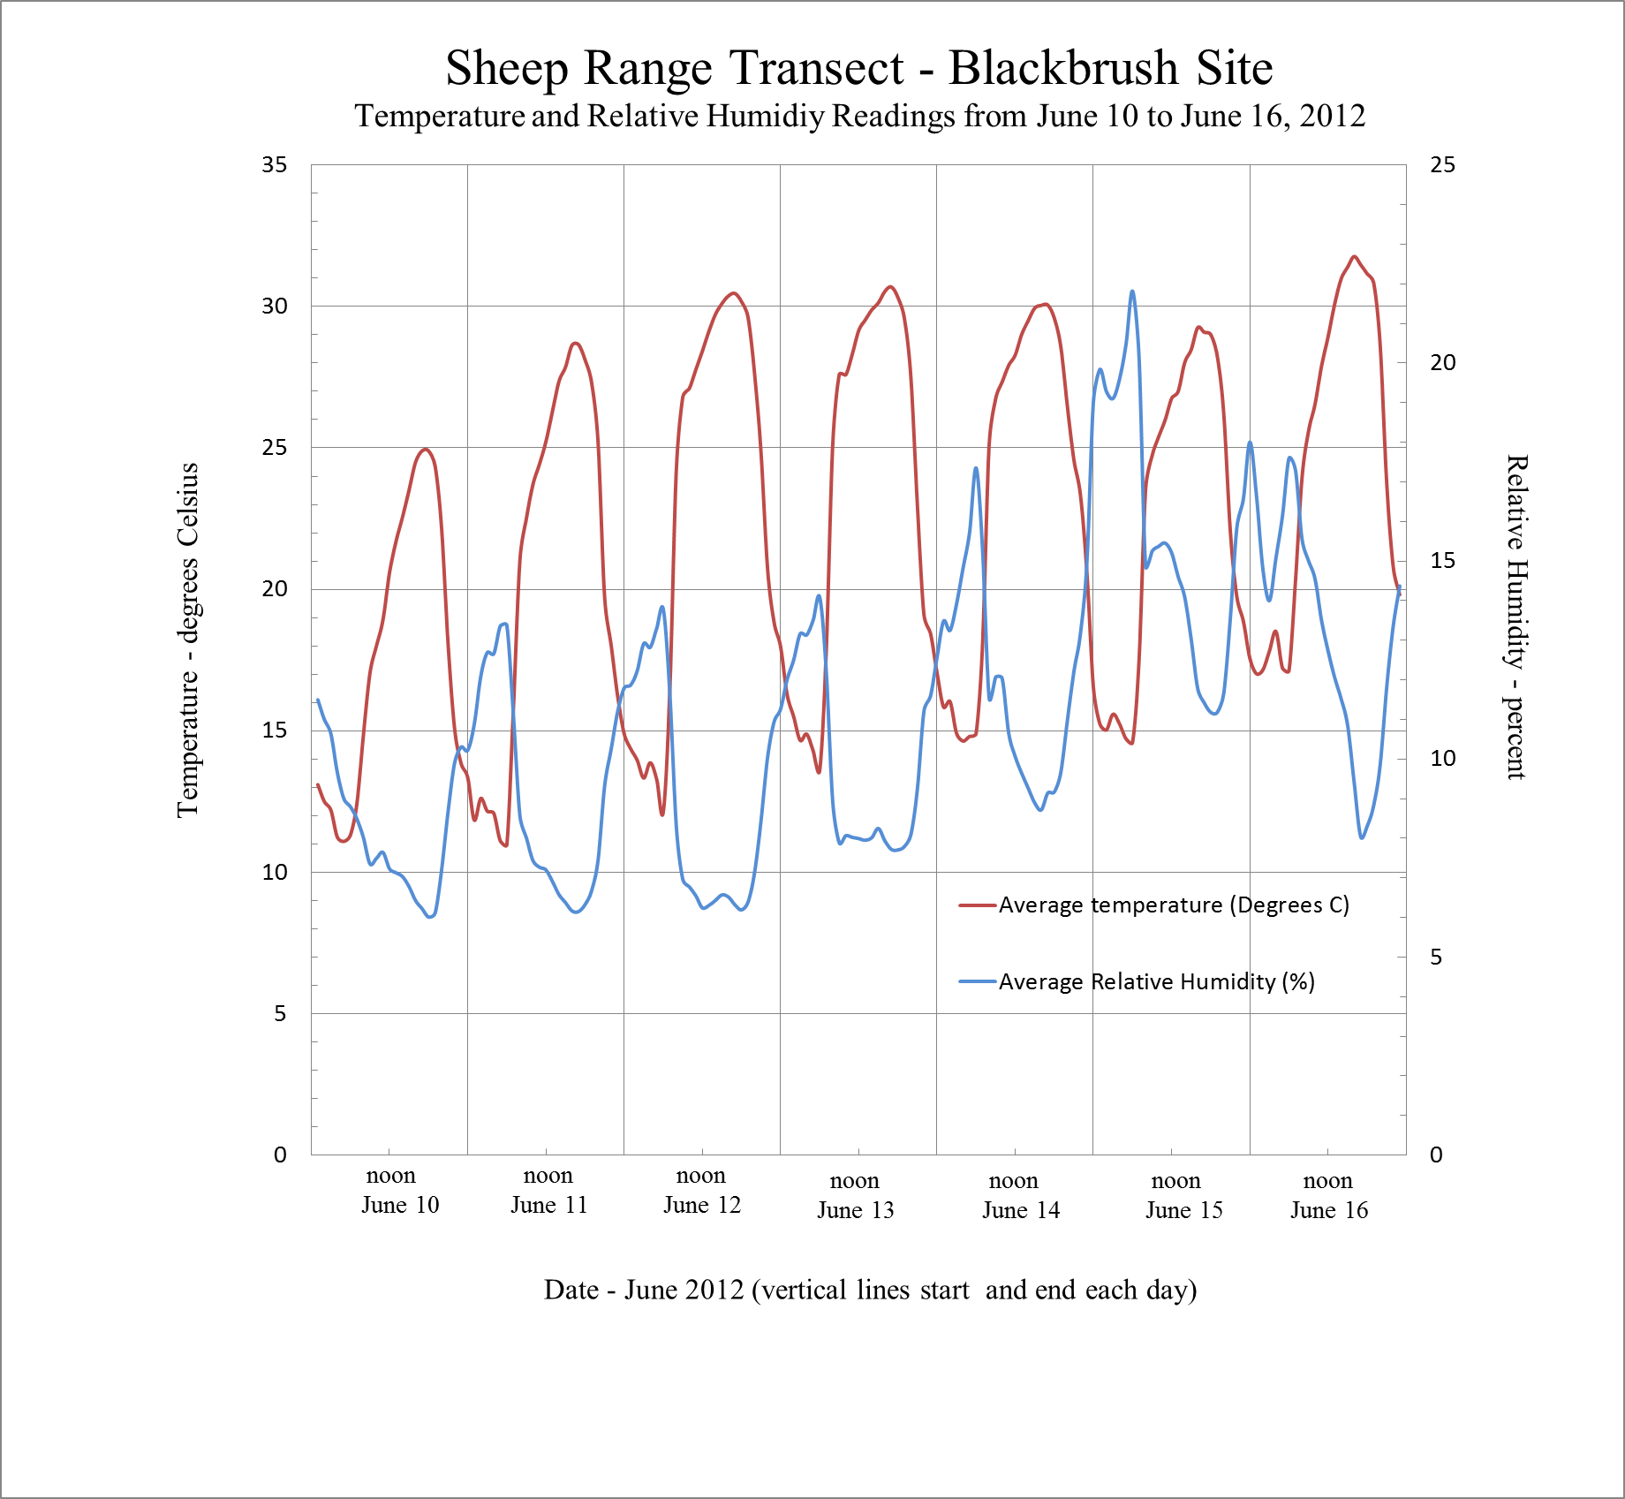

**Figure 1.** Plot of average hourly temperature and relative humidity readings from June 10 to June 16, 2012 at the Blackbrush Station of the Sheep Range Transect, Nevada Climate-ecohydrology Assessment Network.